**EXERCISE: 11**

**DATE: 23.11.2020**

**AIM:**

To write a python program to find the greatest common divisor (GCD) of two integers using recursion

**PROGRAM:**

**def gcd(a,b):**

**if(a==0):**

**return a**

**if(b==0):**

**return b**

**if(a==b):**

**return b**

**if(a>b):**

**return(gcd(a-b,b))**

**else:**

**return gcd(a,b-a)**

**a=int(input("Enter first number:"))**

**b=int(input("Enter second number:"))**

**GCD=gcd(a,b)**

**print("GCD is:")**

**print(GCD)**

**LINK:**

[**http://103.53.53.18/mod/vpl/forms/submissionview.php?id=326&userid=1664**](http://103.53.53.18/mod/vpl/forms/submissionview.php?id=326&userid=1664)

**OUTPUT:**

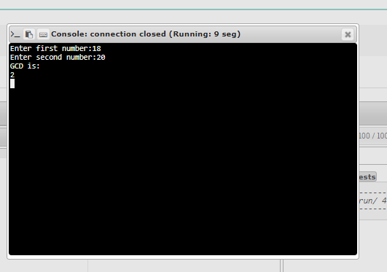

**RESULT:**

The greatest common divisor (GCD) of two integers using recursion is successfully obtained